Experiment 6: Develop a program to classify dry and wet waste using a moisture sensor (DHT22) with Arduino Board
Date : 09.09.2025
Aim:
To develop the program to classify dry and wet waste using a moisture sensor with Arduino Board.
Components Required:
S.No | Components Name | Range/Rating | Quantity
1 | Universal Bread Board |  | 1
2 | Arduino Uno board |  | 1
3 | Moisture sensor | DHT22 | 1
4 | Resister | 330 ohm | 1
5 | LED |  | 1
6 | USB Cable |  | 1
7 | Jumper Wires |  | required

Hardware Setup:

Connect LED with pin D10 and GND
Connect DHT22 pin with A0 and other pin with +5vcc and GND
Arrange the wires as in the following diagram

Connection Diagram: -
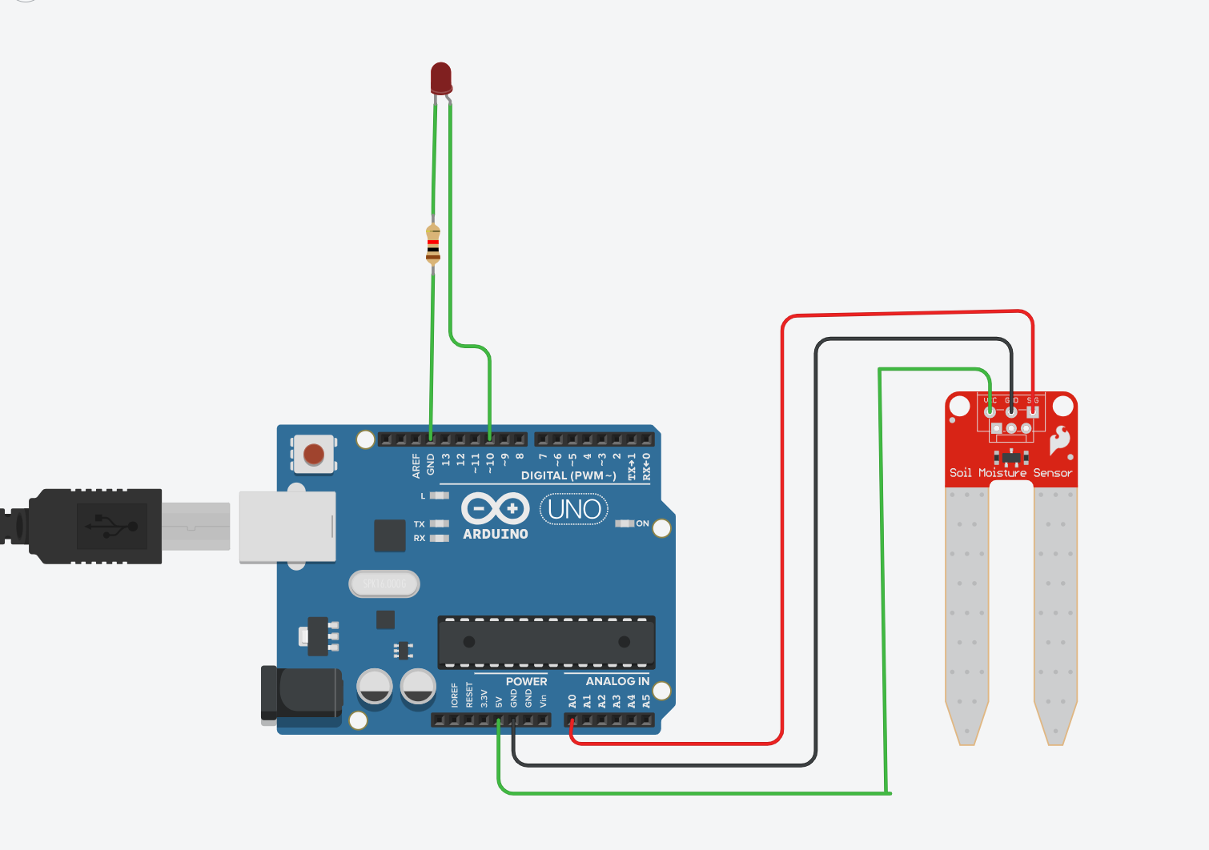

Program
// C++ code
//
int m_data = 0;

void setup()
{
pinMode(A0, INPUT);
Serial.begin(9600);
pinMode(10, OUTPUT);
}

void loop()
{
m_data = analogRead(A0);
Serial.println(m_data);
if (m_data < 21) {
digitalWrite(10, HIGH);
} else {
digitalWrite(10, LOW);
}
delay(10); // Delay a little bit to improve simulation performance
}
Working Observation:
- Initially the LED is glowing mode, since the moisture sensor value is less than the specified value I,e 21.
- It is observed that when the moisture sensor value increases then the sensor value will increases that can be viewed through the serial monitor.
- So, the dryness increases the soil moisture value also increases, therefore the LED which is connected in the pin D10 will stop glowing.

RESULT: The dry and wet is classified by employing the soil moisture sensor with Arduino microcontroller Board and executed successfully.

